There is a requirement to identify sale order lines where the qty ordered for the line is 50% or more of the reorder point qty.

There is a custom checkbox field on the sales order line titled Spike Order Line.

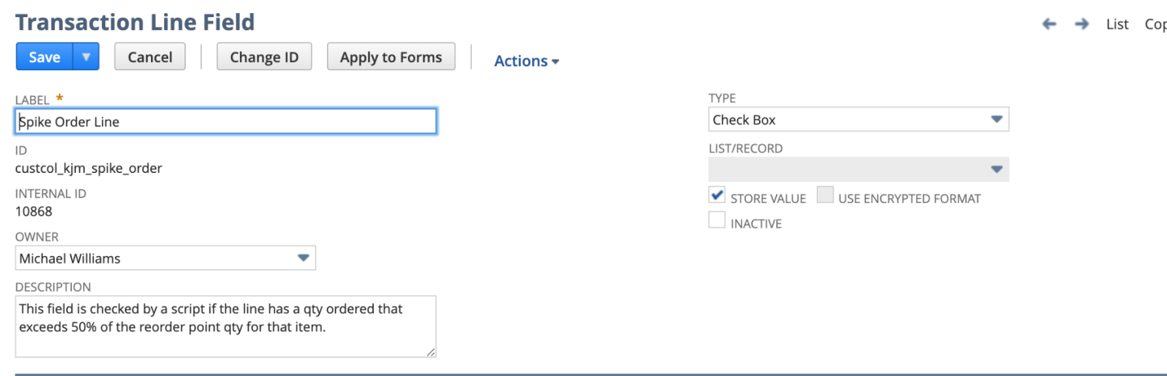

Each item has a reorder point number based on the location for the sales order line.

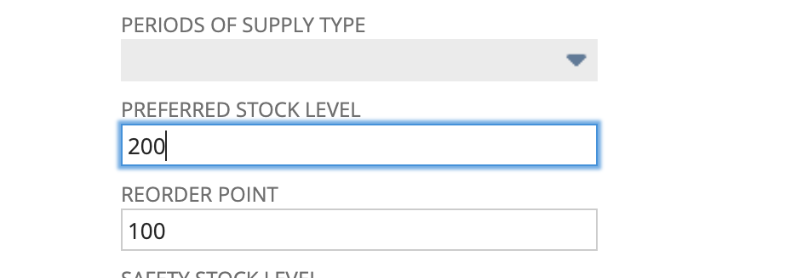

These values are located under the Item Location Configuration based on the location selected on the order.

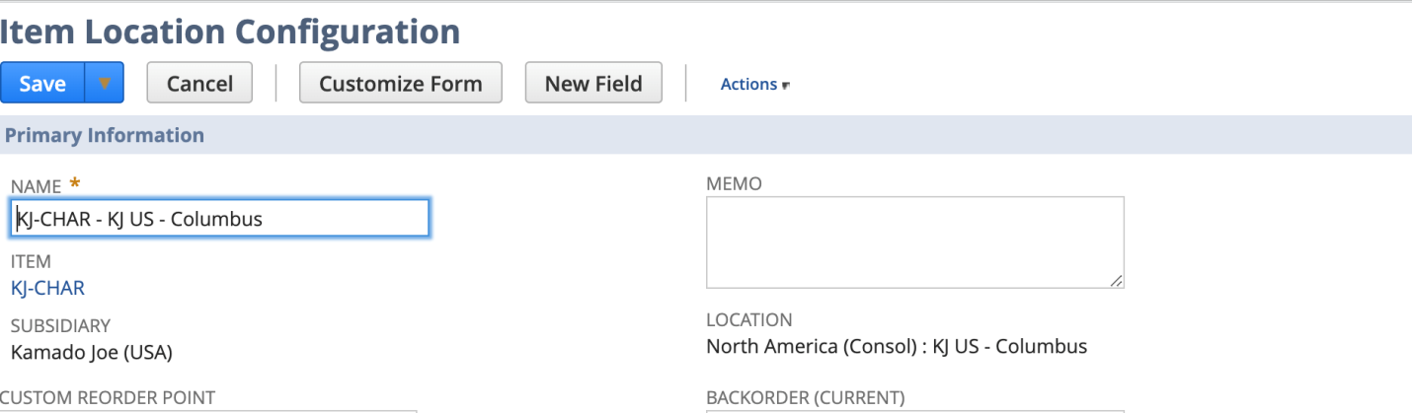

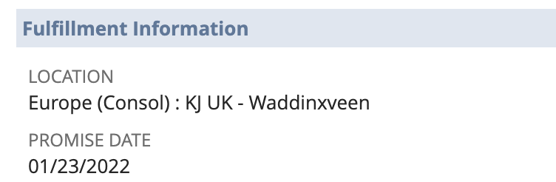

If the qty ordered on that line is 50% or more than the value in the reorder point for that location, then the Spike Order Line box should be checked.

Qty Ordered = 100

Re Order Point = 30